# Multiprocessor assignment

Vo Hieu Nghia

Ex1:

1. P2 reads X

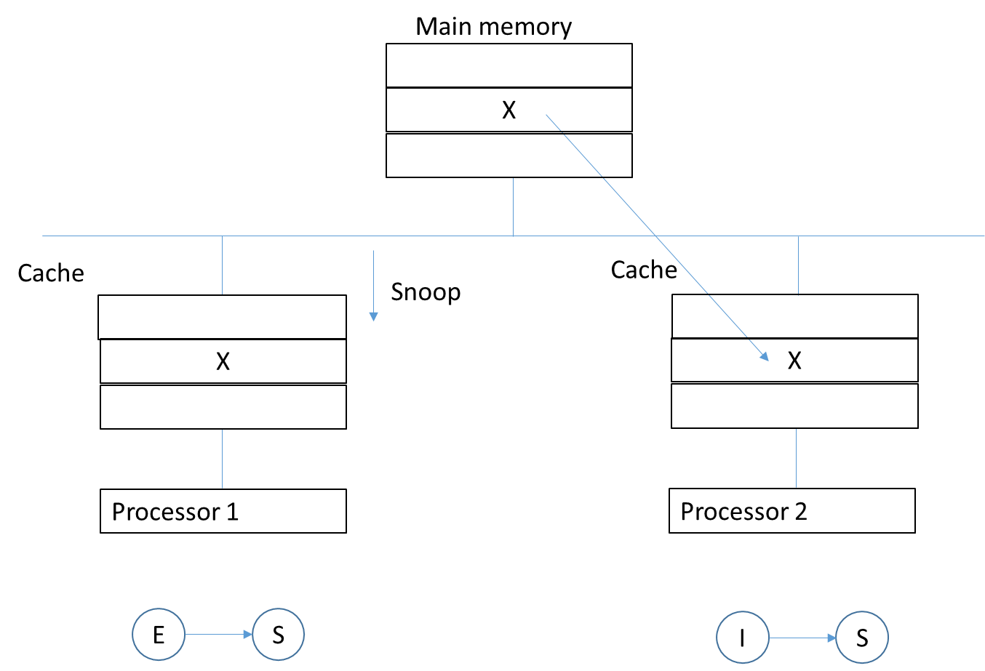

2. P1 writes to X

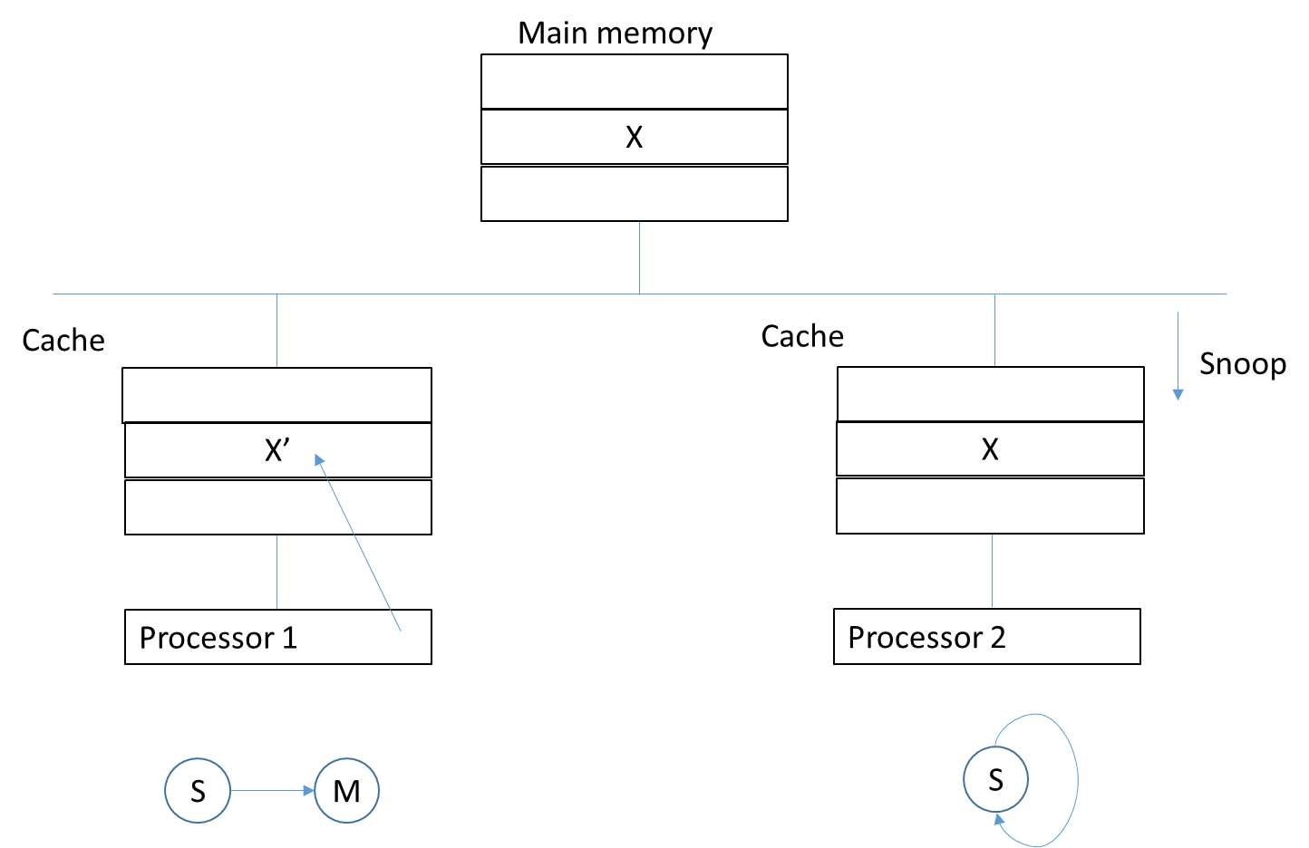

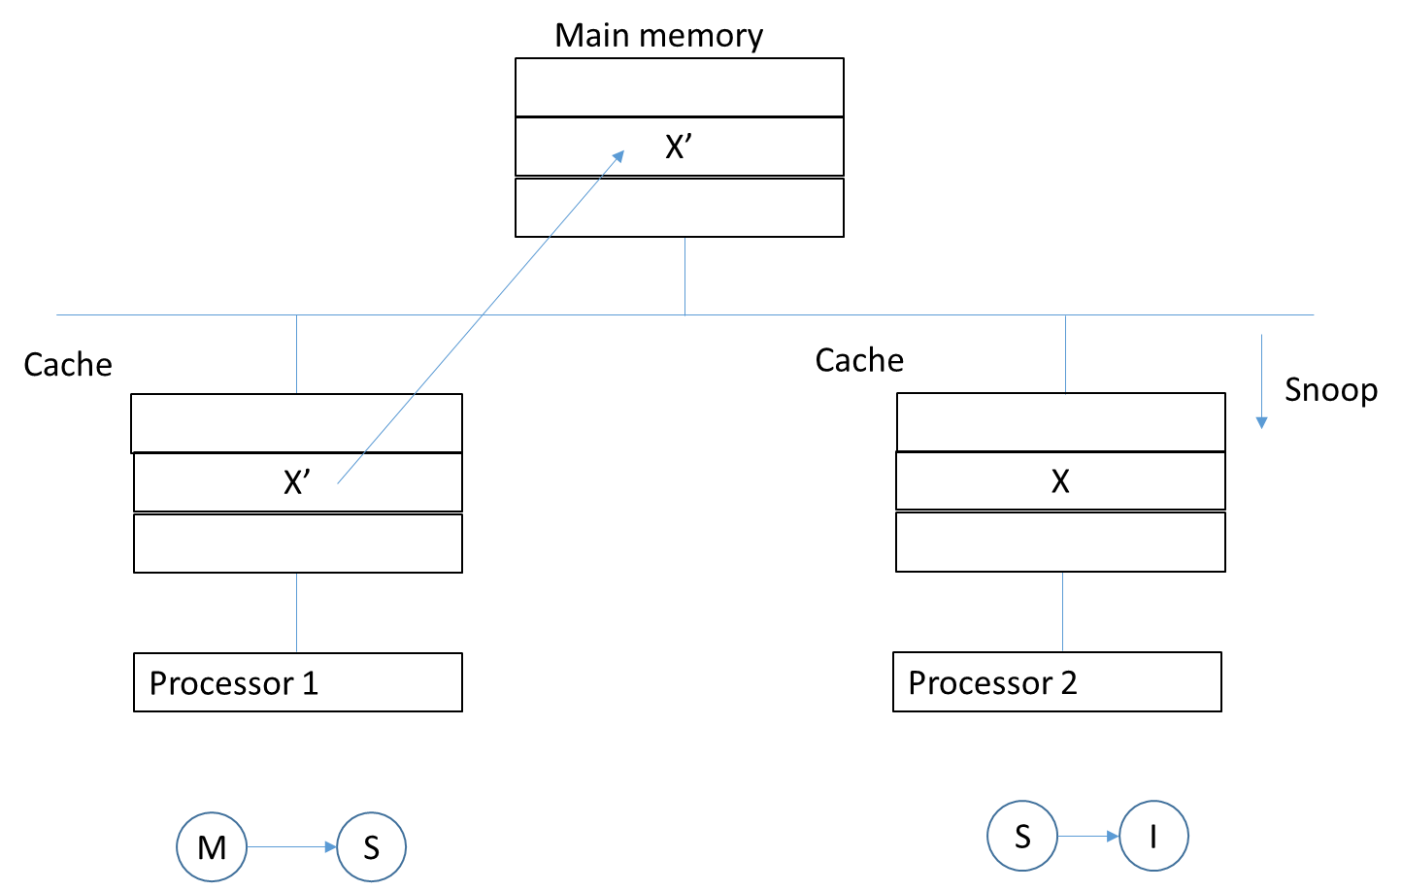

3. P1 writes to X

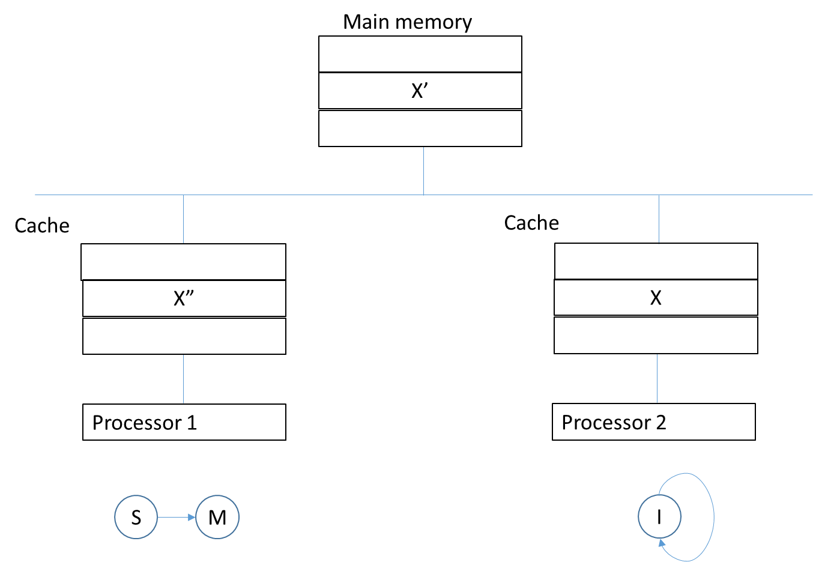

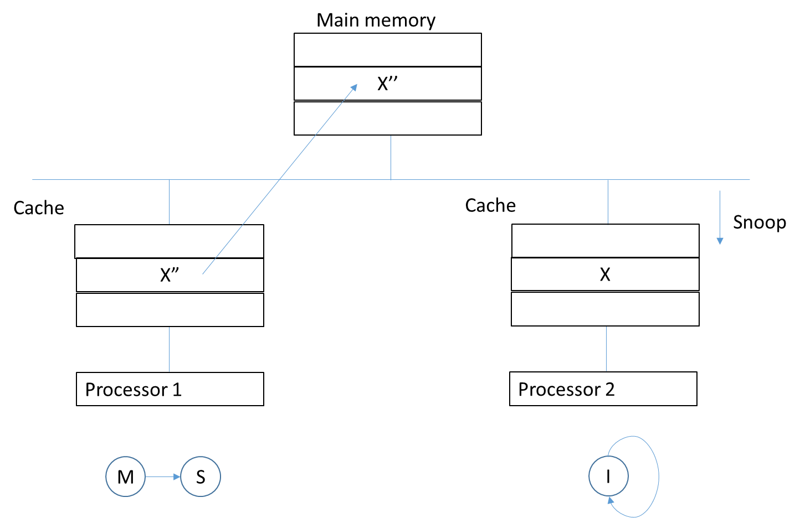

4. P2 reads X

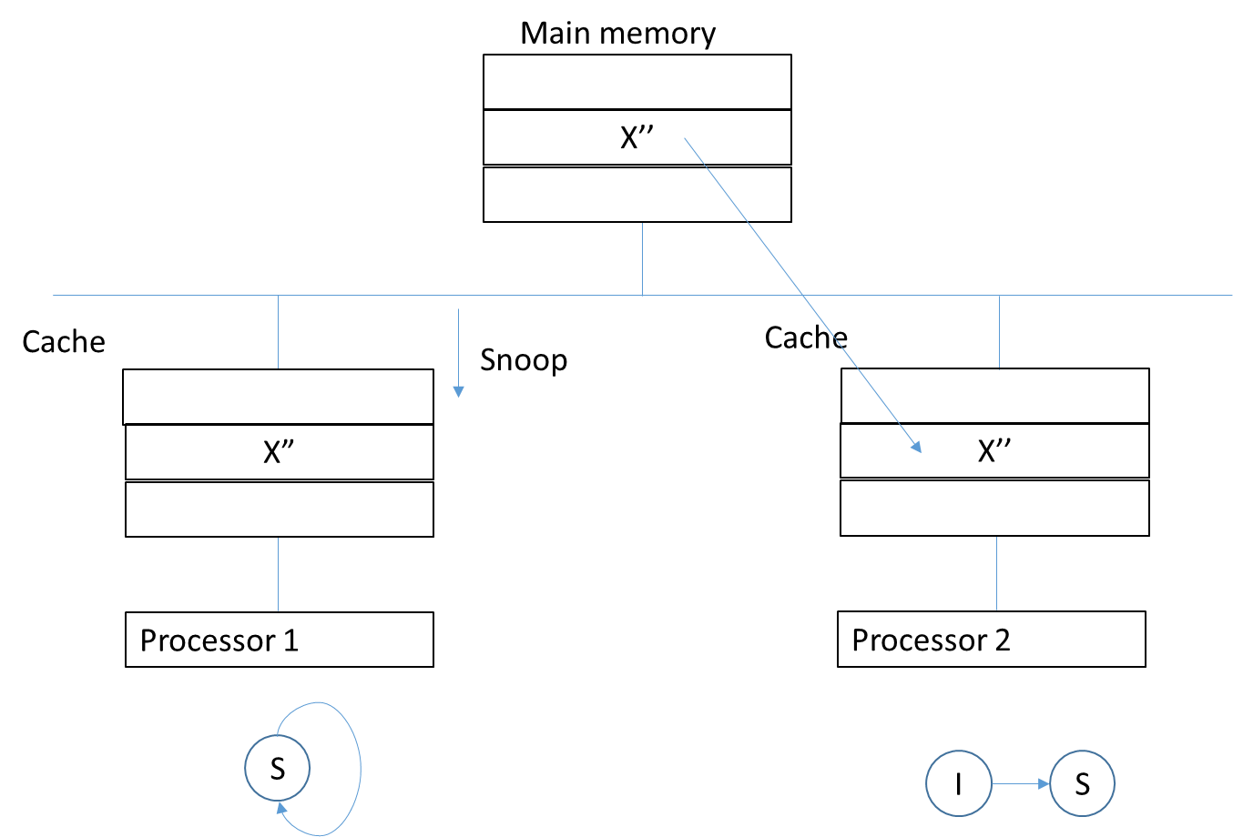

Ex2:

1.

We have:

MIPS = Instruction count / Execution time× 10^6

According to the exercise requirement, the equation will be replaced with symbols:

x = c / CPI . 10^6 🡺 CPI = c / x . 10^6

If α percentage of code executed simultaneously by n processors, the new CPI is:

CPI’ = 1/n . (c/x.10^6). α + (c/x.10^6).(1- α)

The new system MIPS rate is :

x’ = c / CPI’ .10^6 = n .x / α+n. (1- α)

2.

N = 16 , x = 60, x’=540 🡺 α=0.95